TUGAS PRAKTIKUM 5 PEMEROGRAMAN 1

C:\Users\FAZRIL~1\AppData\Local\Temp\ksohtml\wps_clip_image-4242.png

NAMA : FAZRI RAMADHAN

NIM : 4513210018

PRAKTIKUM 5 PEMEROGRAMAN 1

**PROGRAM OBJEK MANUSIA :**

**SOURCECODE**

|  |
| --- |
| public class manusia{  String nama;  public static void main(String[]args){  manusia orang = new manusia();  orang.setNama("Fazri");  System.out.println("Namaku adalah="+orang.getNama());  }  public void setNama(String namaku ){  this.nama=namaku;  }  public String getNama(){  return this.nama;  }  } |

**PRINTSCREEN**

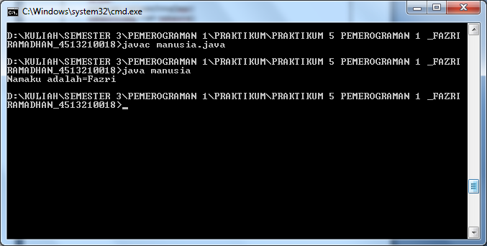

**PROGRAM OBJEK MAHASISWA :**

**SOURCECODE**

|  |
| --- |
| public class mahasiswa{  int nilai ;  public static void main(String[]args){  mahasiswa orang = new mahasiswa();  orang.setnilai(98);  System.out.println("Nilaiku adalah="+orang.getnilai());  }  public void setnilai(int nilaiku){  this.nilai=nilaiku;  }  public int getnilai(){  return this.nilai;  }  } |

**PRINTSCREEN**

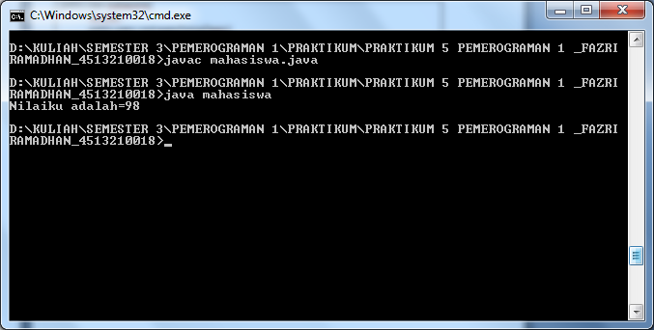

**PROGRAM OBJEK PESAN**

**SOURCECODE**

|  |
| --- |
| public class pesan{  String pesan;  public void main(String[]args){  System.out.println("ini dari method tampilan milik kelas pesan");  }  } |

**PRINTSCREEN**

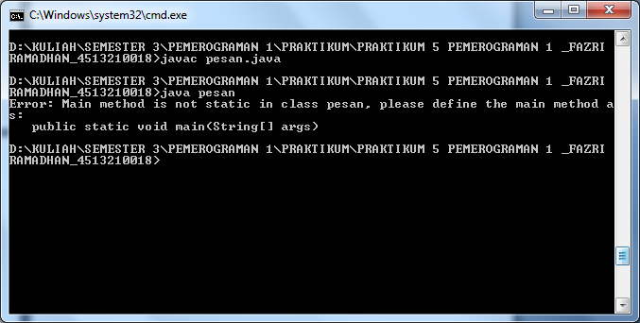

**PROGRAM OBJEK MANGGIL :**

**SOURCECODE**

|  |
| --- |
| public class manggil{  public void main(String[]args){  pesan muncul=new pesan();  System.out.println("muncul.tampilan");  }  } |

**PRINTSCREEN**

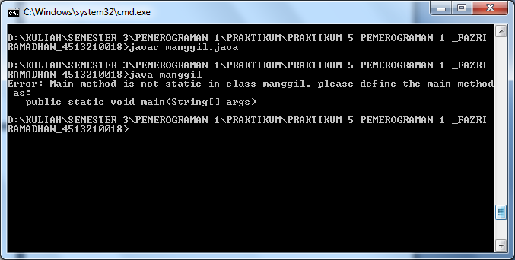

**PROGRAM OBJEK LARIK :**

**SOURCECODE**

|  |
| --- |
| public class larik{  public static void main(String [] args){  int [] data = {4,9,7,3};  int i;  for(i=0;i<4;i++){  System.out.println(data[i]);  }    for(i=0;i<4;i++){  System.out.println("Elemen ke-" + i + " adalah " + data[i]);  }  }  } |

**PRINTSCREEN**

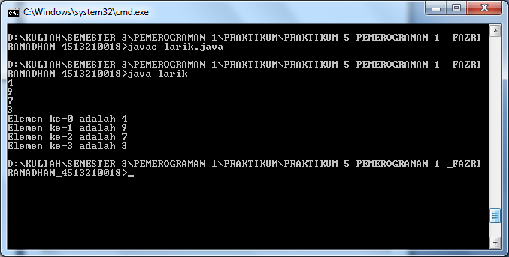

**PROGRAM OBJEK LARIKSTRING :**

**SOURCECODE**

|  |
| --- |
| public class larikString{  public static void main (String [] args){  String[]dataString = {"Makan","Tidur","Mandi"};  int i;  for (i=0; i<3; i++){  System.out.println(dataString[i]);  }    for (i=0; i<3; i++){  System.out.println("Hobisaya = "+dataString[i]);  }  }  } |

**PRINTSCREEN**

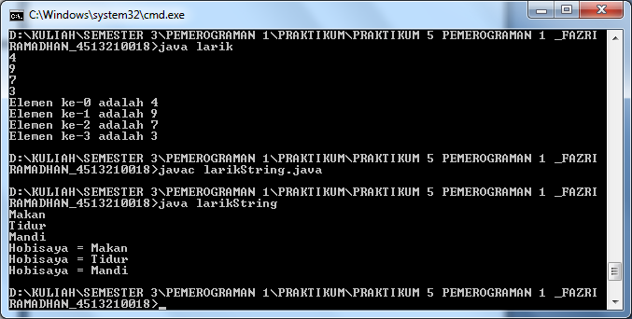

**PROGRAM OBJEK INTARRAY :**

**SOURCECODE**

|  |
| --- |
| import java.util.Scanner;  public class intarray{  public static void main(String [] args){  String [] angka;  int i;  int banyak;  Scanner input = new Scanner(System.in);  System.out.print("MasukkanBanyakangka = ");  banyak = input.nextInt();    for(i=0;i<banyak;i++){  System.out.print("MasukkanAngka = ");  banyak = input.nextInt();  }  }  } |

**PRINTSCREEN**

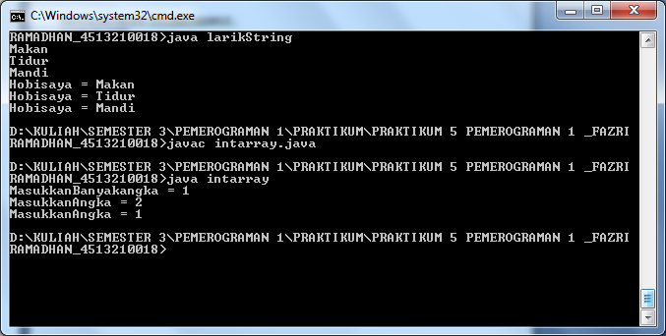

**PROGRAM OBJEK INTARRAYINPUT :**

**SOURCECODE**

|  |
| --- |
| import java.util.Scanner;  public class intarrayinput{  public static void main(String [] args){  int angka[] = new int[10];  int i,banyak;  int jumlah;  jumlah=0;  Scanner input = new Scanner(System.in);  System.out.print("Masukkan Banyak angka = ");  banyak = input.nextInt();    for(i=0;i<banyak;i++){  System.out.print("Masukkan Angka = ");  angka[i] = input.nextInt();  jumlah = jumlah + angka[i];  }    System.out.println("Jumlahnya adalah " + jumlah);  }  } |

**PRINTSCREEN**

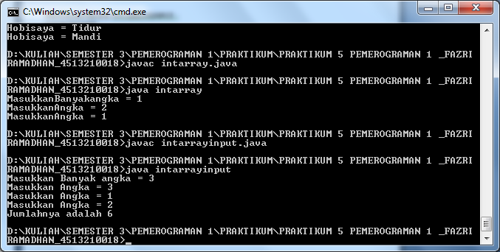

**PROGRAM OBJEK KELUARANARRAY :**

**SOURCECODE**

|  |
| --- |
| import java.util.Scanner;  public class keluaranarray{  public static void main(String [] args){  int angka[] = new int[10];  int i,banyak;  int jumlah;  jumlah=0;  Scanner input = new Scanner(System.in);  System.out.print("Masukkan Banyak angka = ");  banyak = input.nextInt();    for(i=0;i<banyak;i++){  System.out.print("Masukkan Angka = ");  angka[i] = input.nextInt();  jumlah = jumlah + angka[i];  }  System.out.println("Jumlahnya adalah " + jumlah);  if(jumlah%2==0){  System.out.println("\nJumlah termasuk bilangan genap");  }  else System.out.println("\nJumlah termasuk bilangan ganjil");  }  } |

**PRINTSCREEN**

